Finding Your Niche in the Community
Michigan District Missionary Retreat
August 2019

Awkwardness - Change – Relationships - Community - Assimilation

Guess Jeans

“I have become all things to all people so that by all possible means I might save some. ²³ I do all this for the sake of the gospel, that I may share in its blessings.” 1 Cor. 9:22-23
“Vulnerability is the birthplace of innovation, creativity and change.” Brené Brown
“Make fear a tailwind not a headwind” Jimmy Iovine
“Embrace the awkward.” Freddy Berger

Background
- Northside Ministries, Milwaukee, WI – Inner City.
- St. James, North Branch, MI – Rural, auto workers.
- Hope, Toronto, Canada – Urban, 1st gen. immigrants.
- Carbon Valley Lutheran, Firestone, CO – Suburban, affluent.

Disclaimer – We all can’t be Ma_ _, B_r_h_ _ _z.
- Success leads to success
- Always a backstory
- Know your self Know your ________________, Know your _________________.

Wind Vectors

^{“14} I am obligated both to Greeks and non-Greeks, both to the wise and the foolish.¹⁵ That is why I am so eager to preach the gospel also to you who are in Rome. ¹⁶ For I am not ashamed of the gospel, because it is the power of God that brings salvation to everyone who believes: first to the Jew, then to the Gentile.” Romans 1:14-16

- Everybody is like some other people - Human _________________
- Everybody is like all other people - Human __________________
- Each person is utterly unique - Human __________________
Kessel…Wendland
The View Has Changed

Michigan Religious/Social Make Up
Rank general levels of “religiosity”, 1 being low religiosity, 8 being highest.

- ______ Bible Belt/Deep South
- ______ Michigan
- ______ West Coast
- ______ Mountain States
- ______ Plains States
- ______ Pacific Northwest
- ______ Texas
- ______ Northeast

Choluteca Bridge

Society and People have Changed

- Distrust of Institutions
  - Witnessed or possible impact?
  - Solutions?
- Increased Mobility & Movement
  - Witnessed or possible impact?
  - Solutions?
- Access to Content
  - Witnessed or possible impact?
  - Solutions?
- Digital Connectivity
  - Witnessed or possible impact?
  - Solutions?
- Increased Isolation
  - Witnessed or possible impact?
  - Solutions?
- Consumer Mentality
  - Witnessed or possible impact?
  - Solutions?

- Expectations (minimum level of competency)
  - Witnessed or possible impact?
  - Solutions?
- Indifference to Doctrine
  - Witnessed or possible impact?
  - Solutions?
- Service Minded
  - Witnessed or possible impact?
  - Solutions?
- Socially Oriented
  - Witnessed or possible impact?
  - Solutions?
- Other?
  - Witnessed or possible impact?
  - Solutions?

Jaipersaud Sharma

Prospect Distance
Rank the relative “distance” earthly speaking prospects have to travel. 1 being closer 6 being furthest.

- ______ Practicing Jew, Hindu, Muslim
- ______ Non-Practicing Catholics
- ______ Non-Practicing Baptists/Non-denoms
- ______ Other Lutherans
- ______ Atheist/Secular
- ______ Apatheist’s/Nones

Grampa Tom

- Developing relationships take ____________________ than ever before.
- Developing relationships happen ____________________ out than ever before.

Relationships Matter

“I thought of each person as a book who had a story that I wanted to read.” Professor Brug…Mark Birkholz…a Little Made Up.
- You have to have a ___________________ about people and that means things will get messy.

“Before people buy from you, they have to buy into you.” Carlton Douglas Ridenhour

- There needs to be __________________ in what you do and who you are.

“Kicking over stones” 417 bc Polycrates/Mardonius…Mike Benrud…a Bird.

- There needs to be ___________________ and timing matters.

¹ Jesus entered Jericho and was passing through. ² A man was there by the name of Zacchaeus; he was a chief tax collector and was wealthy. ³ He wanted to see who Jesus was, but because he was short he could not see over the crowd.⁴ So he ran ahead and climbed a sycamore-fig tree to see him, since Jesus was coming that way.⁵ When Jesus reached the spot, he looked up and said to him, “Zacchaeus, come down immediately. I must stay at your house today.” ⁶ So he came down at once and welcomed him gladly. ⁷ All the people saw this and began to mutter, “He has gone to be the guest of a sinner.” ⁸ But Zacchaeus stood up and said to the Lord, “Look, Lord! Here and now I give half of my possessions to the poor, and if I have cheated anybody out of anything, I will pay back four times the amount.” ⁹ Jesus said to him, “Today salvation has come to this house, because this man, too, is a son of Abraham. ¹⁰ For the Son of Man came to seek and to save the lost.”
Luke 19:1-10

- Where was Jesus headed and what was he on a mission to do?

- Who was Zacchaeus, job, position in society, etc…?

- Why would Jesus stop for Zacchaeus?

Propinquity

- Be Available, Personally, Professionally & Institutionally
  - Unhurried Time + Proximity + Doing Something, Food/Drink = ___________________.
  - Conversations + Vulnerability = _________________(____________).
Be Available Ideas

Planned
- Cook Out and Invite Neighbors.
- Invite neighbors, friends, co-workers for some fire pit time.
- Say yes to invitations (graduation, Halloween, Christmas, New Years, school plays, sports games).
- Go to your Home Owners Association Meeting.
- Volunteer for your city.
- Hold a Super Bowl Party.
- Wine or craft beer tasting party.
- Go for a walk…run…together.
- Invite your kids team parents over to get to know them.
- Invite someone to go out for lunch, or dinner.
- Team up for a garage sale.
- Drop some cookies at your neighbor’s place during Christmas.
- Check out the new restaurant, beer garden, etc… and bring someone with you.
- Your own ___________________________.

Spontaneous
- Hang out in your front yard rather than the back yard.
- Enjoy a beer, wine or sweet tea…out front. Imagine that.
- You like dogs…others like dogs…walk your dog and chat (not cat no one likes cats).
- Hang at the dog park and in addition to playing with your dog chat someone up.
- Enjoy your neighborhood pool or park.
- Walk…run…bike…stroller…hike on your local paths.
- Be quick to help, cleaning gutters, working on a car, anything.
- Get coffee and actually go in.
- Offer to babysit for weary parents.
- Become a regular at a local restaurant. Get to know the waiter or waitress.
- Talk with the parents of the other kids.
- Bring morning treats to work.
- Your own ____________________________.

Community Matters

⁴ This is what the Lord Almighty, the God of Israel, says to all those I carried into exile from Jerusalem to Babylon: ⁵ “Build houses and settle down; plant gardens and eat what they produce. ⁶ Marry and have sons and daughters; find wives for your sons and give your daughters in marriage, so that they too may have sons and daughters. Increase in number there; do not decrease. ⁷ Also, seek the peace and prosperity of the city to which I have carried you into exile. Pray to the Lord for it, because if it prospers, you too will prosper.” ⁸ Yes, this is what the Lord Almighty, the God of Israel, says: “Do not let the prophets and diviners among you deceive you. Do not listen to the dreams you encourage them to have. ⁹ They are prophesying lies to you in my name. I have not sent them,” declares the Lord.¹⁰ This is what the Lord says: “When seventy years are completed for Babylon, I will come to you and fulfill my good promise to bring you back to this place.¹¹ For I know the plans I have for you,” declares the Lord, “plans to prosper you and not to harm you, plans to give you hope and a future.” Jeremiah 29:4-11

- Describe the setting for our text?

- After hearing verses 5-7 what might be the reaction from the Israelites?

- What is God saying to the Israelite’s concerning their community?

Spheres of Community
List all your “communities.” A good definition of “community” is anyone you regularly spend time with.

Freedom to Focus Compass, or…

- What’s _________________?
- What do I __________________ at?
- What _____________ does it have (church or personal)?

Wives Matter
“Many prospects connect with your wife and family, first, as much and more than you.” ________________

Community Contact Point Ideas

- Canvassing
- Mailers
- Signs
- Arts & Cultural Committee
- Town Planning & Zoning Commission
- Chamber of Commerce
- Rotary
- Non-profit Board Member
- School Board Member
- Guardian ad Litem
- Foster Care
- Men’s/Women’s Shelter
- City Festival Planning
- Trail Board
- Downtown Development Board
- Cycling Club
- Running Club
- Young Professionals
- Board for Music and Beer Festival
- Public School Board
- Downtown Cleanup & Revitalization
- Neighborhood Planning Committees
- Soccer League
- Softball League
- Historical Walk (Jane’s Walk)
- Flag Design Committee

- Teacher of the Year Committee
- Basketball Coaching
- Soccer Coaching
- Volleyball Coaching
- Non-profit Network
- Half Marathon for Autism Volunteer
- Historical Society
- Art and Music Festival Organizer
- Brass Quintet Performance Usher
- City Softball Tourney
- Museum Board Member
- Community Liaison
- Home Owners Association
- Business Owners Association
- Basil Harvesting for Local Cidery
- Halloween Safe Night Volunteer
- Small Business Saturday Organizer
- Carbon Valley Help Center (food bank) Committee Member
- School Play Volunteer
- Write for Local Paper
- I Have a Dream Foundation
- Odyssey of the Mind Coach
- Home Brew Club
- Book Club
- Moms Groups
- Wild Cider Wine and Beer Festival
- Adopt a Trail
- Blues, Brews and BBQ
- Miners Day Festival
- 4th at Firestone
- Historical Society
- Next-door Social Site
- Nursery Giveaways
- Neighborhood BBQ’s
- Watchdog (dads in schools)
- Craigslist – Buying stuff
- Weather Spotter Training
- Facility Maximization & Exposure

Love Local Challenge – See Addendum

Assimilation

Assimilation/Member Involvement

1975-95 CONVERSION (church) CAUSE COMMUNITY
- Bill Hybels and the Willow Creek model/influence
- Nominal Catholics look elsewhere and de-churched Protestants do as well
- Mega churches offering anonymity & programs either attract Boomers or result from Boomers
- The essential cause was to build more churches and fill them

1995-10 COMMUNITY CONVERSION (church) CAUSE
- Gen Xer’s and even more so, Millennials, show up and seek relationships more than programs.
- “Sticky Church” revamps a long-standing tradition among Evangelicals, small group study.
- “house churches” appear, though they’re “more about the house than the church” (Stetzer).
- “emerging church” appears, though it’s waned, just as did “Grunge” and “Mars Hill”.
- The essential cause was to form semi-organized spiritual relationships leading to “conversion”

2010-?? CAUSE COMMUNITY CONVERSION (church)
- Post-modern, Post-Xian, Anti-Institutional, A-political, “Spiritual, not Religious”, “None”
- In the sub-conscious of 79 million Millennials “community service” has been planted
- “Does the church care about me and the community?”
- The essential cause: “we will be a part of the community, not apart from the community”
- Even more than pre-2010, people want to participate both on campus and off campus before any thought is given to “joining”

An Organic Model
^{“27} Now you are the body of Christ, and each one of you is a part of it.” 1 Cor. 12:27

- Less _______________ more _____________________.
- ________________ in word & action by Pastor…wife…leaders…
- Clearly communicated _______________ & _________________.
- Many ________________ to get connected in.
- High & clear _____________________.
- Generosity produces ___________________...Love produces __________.
- Structure that _______________ & _______________ prospects to come.
- Simplicity & __________________ when prospects come.
- Members _________________ members.

Prospect Management - WELS School of Outreach
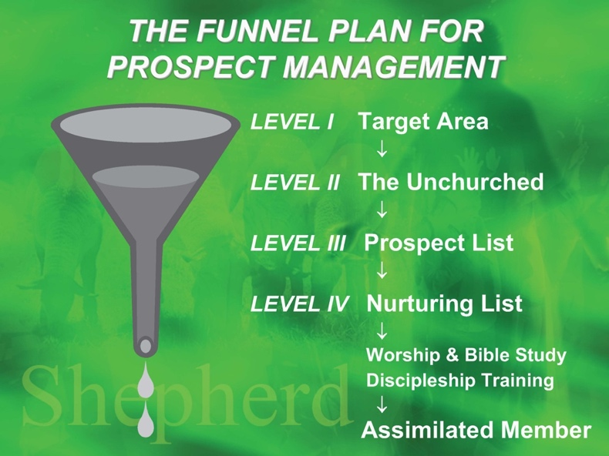
An Organic-ish Flow Chart
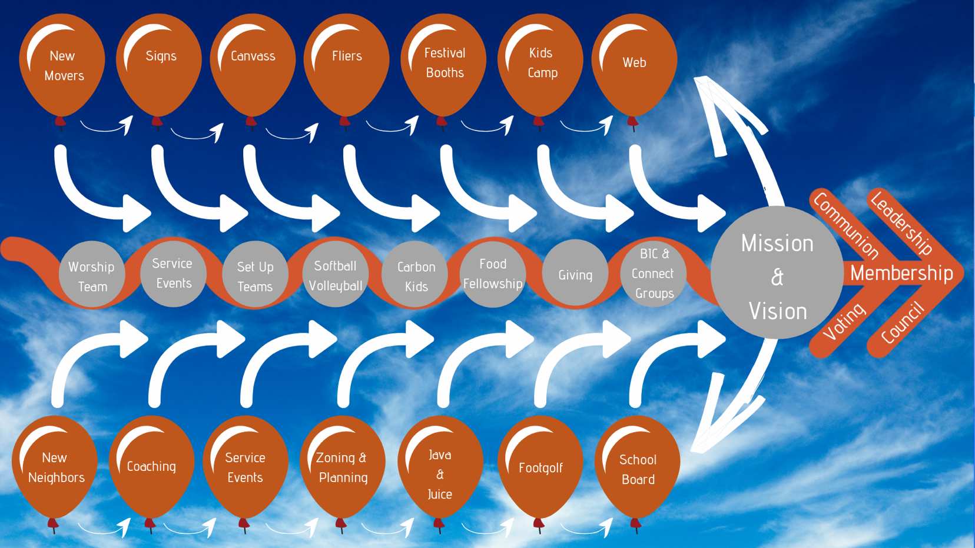

“⁶ I planted the seed, Apollos watered it, but God has been making it grow. ⁷ So neither the one who plants nor the one who waters is anything, but only God, who makes things grow.”
1 Cor. 3:6,7

Addendum/Examples
First Visit Follow Up
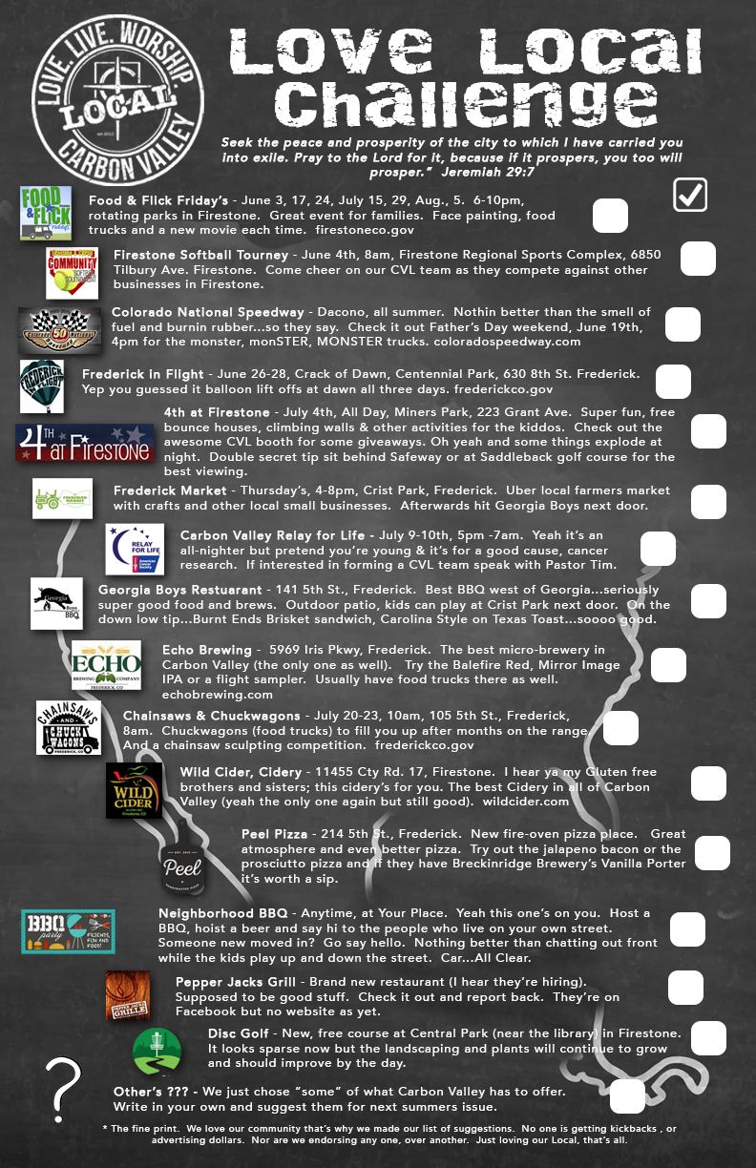
First Visit Follow Up
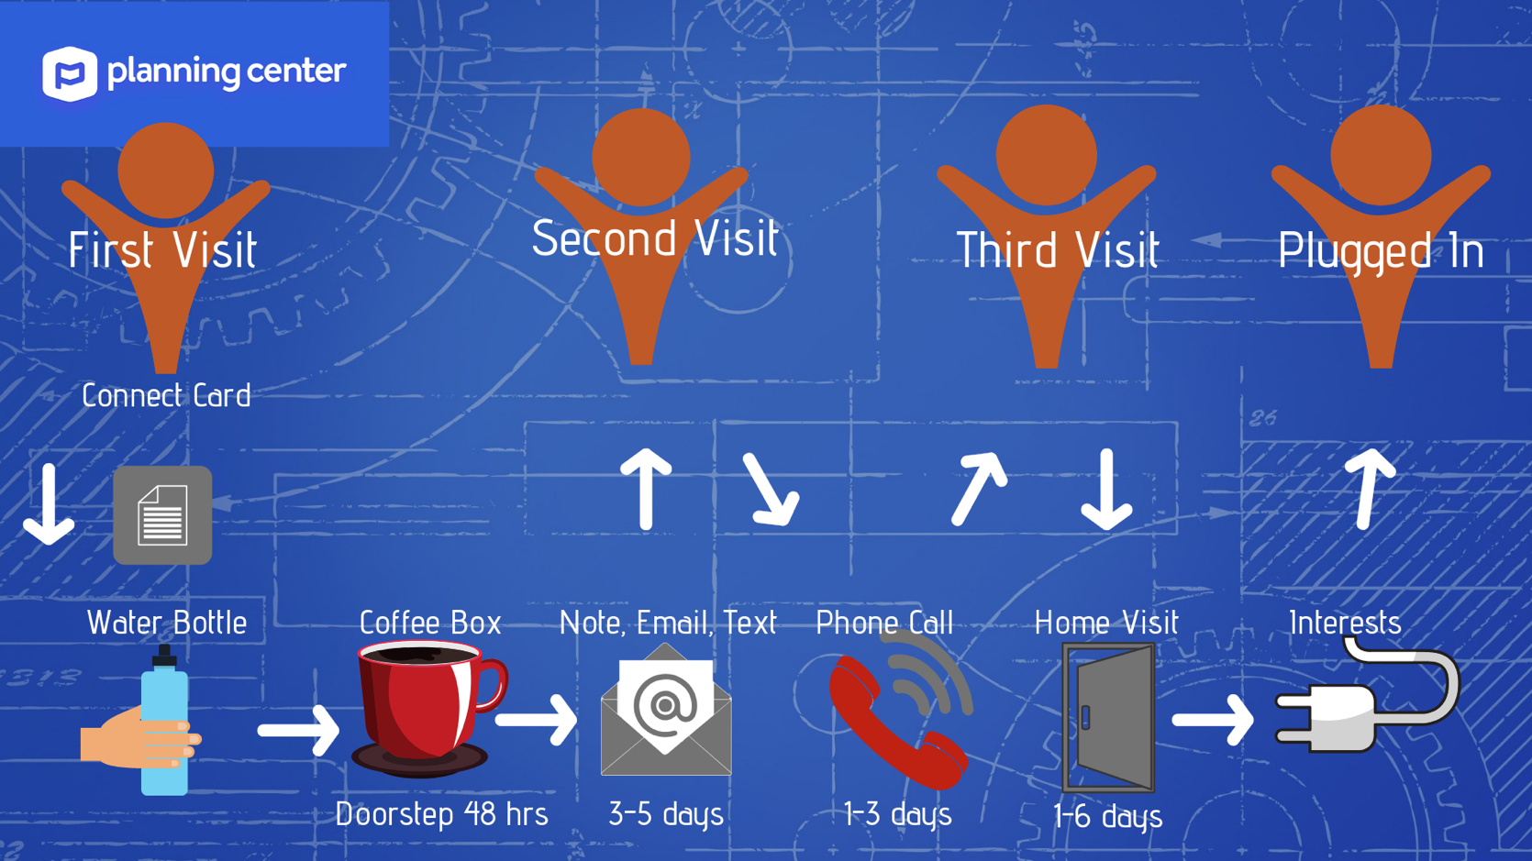

Church Planters Intensive List
For details on Church Planters Intensive contact Jared Oldenburg, pastor@eternalrock.com

CPI “Better than 80%” Checklist:
(Caveat, this is a working list)
Essential
Nice
Utilizing your Gifts
- Completed Free to Focus Compass?
- Completed written plan for personal growth physically-spiritually-professionally?
- Completed ideal workweek.
- You have a morning routine.
- You have an evening routine
- You have planned out your vacations and days away for next 12 months.
- You have a plan to read at least a book a month.
- You have scheduled days to plan out each quarter/trimester when you will not be interrupted (for the upcoming quarter). Basically, is are planning days on your calendar?
- You “theme” your work days rather than just trying to get stuff done every day.
- You have a day off.
- You have a church planting mentor (brainstorm/coach/confess)
- You give at least 10% to the mission.
- You are living within you means (don’t have debt besides your house and possibly a car).
- You have a strategic plan to get into the community.
- You are not the bottleneck.

Timeline
- Completed timeline for “prospects stream”
- Completed timeline for overall launch.
- Completed timeline for “core group stream.”
- You have an idea of your timeline to get a building.
- Start early geographic/demographic work for building location. Start developing those relationships if applicable.

Building a Vision
- Completed draft of your “story brand.”
- You can say your 30-second pitch rehearsed with real people.
- You have a rough draft vision for:
  - Worship
  - Grow
  - Serve
  - Reach
  - Admin
  - Staff
- Your core people know your story brand because it reflects what is true about your church.
- You have completed the VTO rough draft.
- You are not changing vision for one family/person.
- You are asking big.
- You have asking (or at least have a timeline) to make “the ask” to see if people are committed to you church.

Worship
- You started looking for a worship location the month you arrived.
- You have a score sheet to evaluate worship. You have mapped out what your worship will look like.
- You have a plan for next 6 months of sermons laid out.
- You have music planned for next 3 months.
- You have taken and inventory and determined or purchased what you need for launch (communion ware, etc.)
- Volunteers are organized into teams rather than just people who show up to help.
- You have a location for worship at least 3 months before launch.
- You are planning “preview” or practice services.
- You have a system online for programing/planning music like www.planningcenteronline.com

Grow
- You have plan for Bible Study.
- You have a way to encourage and get people in the Bible outside of church.
- If you have a nursery/kids program you have a system to get background checks and you always have two adults (or adult and teen) working with kids.

Serve
- You are committed to asking people personally to volunteer.
- You have a list of real-time volunteering needs.
- You have a policy of how to get people involved early without offense (under the leadership of a member for example).
- You have ideas of how to serve the community instead just inside your church.
- You have a policy on how to thank volunteers systematically.

Reach
- You are trying to meet people every day.
- You have a system to make sure you are regularly following up with people.

Systems
- You have a “template” for making systems.
- Completed systems for all aspects of worship?
- You have a template so system for events?
- Completed system for first time guest to advocate for your church.
- Competed system for first time donor-to become regular donor and beyond.
- Completed system to plug in people for volunteering (thanking, scheduling, recruiting, etc.)
- System in place for growing leaders (and future leaders).

Administration
- You have a great website.
- You have a great website address.
- You have a Facebook account.
- You are incorporated.
- You have completed you state tax exempt filing (for sales tax exemption).
- You have linked your tax-exempt certificate with Amazon.com (not smile, but linking your tax exempt so you can order tax free).
- You have ways volunteers can plug in to help with admin tasks.
- You have one data silo for giving, prospects.
- You have an eLetter.
- You have a church name.

Staff
- You have at least one part-time person who compliments your strengths.
- You are willing to pay an essential person $50/wk to make sure things get done.

Money
- You have a way to thank first-time donors.
- You have started a designated building fund.
- You know how much you can spend without going over budget.
- You have a plan to be off subsidy in less than 12 years.
- You have a way (as soon as possible) to receive offerings online.
- Your finances are track via the cloud verses a downloaded program.

Book Suggestions
Compiled from Church Planters Intensive, Matt Rothe, Mark Birkholz and Tim Spiegelberg

Book List for Church Planters

Must-Reads Before You Launch (an ever-changing list)

These are listed in a suggested order.

- Everything that you can get your hands on about your city and community.
  - Read everything you can about your city: Reports, demographics surveys, articles, books, histories, etc. Use synods “Mission Insite” subscription.
- Something specific to your church’s spiritual context (you’ll know this based off #1)
  - If you’re planting in a global city, read Center Church. If you are planting in an area with high-poverty, read Toxic Charity. If you are planting in a conservative area, maybe read something on church and state. If you are planting in a college town… If you are planting in an area with a large LGBTQ+ community… You get the point.
- The Nuts and Bolts of Church Planting (Aubrey Malphurs) For my money it is precisely what the sub-title claims: a guide for starting any kind of church. Loaded with practical ideas. Free of most denominational and terminology baggage.
- Church Unique (Will Mancini) As with Essential Church, some of our new group have used this volume for their studies during the year of preparing to launch. It’s also valuable for understanding why organic or member-based planning is important before entering into strategic planning.
- Launch (Nelson Searcy) Others think it’s the best “short primer” on church-planting. Maybe. (“I think Searcy is exhausting to read, but he has a few worthwhile points.”- Rothe)
- Essential Church: Reclaiming a Generation of Dropouts (Thom and Sam Rainer) This is what several church planters have taken their core groups through in a Bible Study format. It helps establish a mission mindset for lay people. Underlying premise is that the 20-35 crowd doesn't see church as "essential" and what to do about that reality. Many of our new starts have used this in formulating their “congregational philosophy of worship and ministry”
- unChristian: What a New Generation Really Thinks about Christianity…and Why It Matters (Kinnamann). This is the only one I have read on this list. Some guys say this is better than Essential Church. They’re right, but it is for pastors to read and dedicated lay-members, not really for Bible Study formats, but maybe.
- Theories, To-Dos, Tactics, And Tools Of Digital Marketing For Churches (Rothe). Yea, I wrote this paper for a conference, but if I ever had a year of pre-launch again, I would do everything in this paper step-by-step. 
- Building a Story Brand (Miller). The best marketing (that is, really evangelism) book you will read for our current cultural context (read over-marketed and over hyped). It is a necessary read and the applications to ministry are endless.
- Meet Generation Z (White) This and the next book are great reads on reaching the largest unchurched generation in the history of the world.
- iGen. (Twenge) Why Today's Super-Connected Kids Are Growing Up Less Rebellious, More Tolerant, Less Happy--and Completely Unprepared for Adulthood--and What That Means for the Rest of Us.
- Traction (Wickman) This will assist you in organization. You don’t want to “wait” to get organized. Start acting like you’re a church double your size and age now

Can Wait Until After launch
- The Culture Code: The Secrets of Highly Successful Groups (January 30, 2018) by Daniel Coyle
- Sticky Teams: Keeping Your Leadership Team and Staff on the Same Page (April 11, 2010) by Larry Osborne
- The E-Myth Revisited: Why Most Small Businesses Don't Work and What to Do About It (October 14, 2004) by Michael E. Gerber

Non Mission Books (leadership, sociology, etc…)
- Extreme Ownership (Jocko Willink)
- Strengths Finders 2.0 (Tom Rath)
- Range (David Epstein)
- Tipping Point (Malcom Gladwell) – Anything by Gladwell is good.
- Quiet (Susan Cain)
- Daring Greatly (Brene Brown)
- The Secret Thoughts of an Unlikely Convert (Rosaria Champagne Butterfield)
- The Art of Neighboring (Jay Patrick & Dave Runyon)
- The Rise of the Nones (James Emery White)
- Start with Why: How Great Leaders Inspire Everyone to Take Action (Simon Sinek)
- Leaders Eat Last: Why Some Teams Pull Together and Others Don't (Simon Sinek)
- The 21 Irrefutable Laws of Leadership: Follow Them and People Will Follow You (John Maxwell)
- Crucial Conversations Tools for Talking When Stakes Are High, Second Edition (Kerry Patterson)

A Year in the Life of a Church Planter

CVL Case Study

Disclaimer – The below information was developed in response to a friend and fellow church planter who asked for details on what I did in my first year of planting. It was put together quickly as I had just launched worship and had limited time. I put the below together based off of my emails, BHM reports, and my sketchy memory. I think its valuable to see but it isn’t written in stone. That’s my way of saying excuse and lack of clarity, grammar or polish. If you have any questions or want clarity feel free to reach out. pastor@carbonchurch.com

Thanks Tim Spiegelberg

Carbon Valley Lutheran was a new church plant in 2014.
CVL is located in Firestone Colorado, a northern suburb of Denver.

Corporate Stuff to Be Done ASAP

Pick a Name
I literally went through about 500 names. Every WELS church in Colorado. Every Church in Carbon Valley. Every church in the Synodical yearbook (so many "shepherd of ______'s). I created a Big Board with possibilities (see below). I bounced them off of peers, core members, family members, prospects (prospects were actually super valuable). I checked web presence as well and already was thinking about web domains etc... for ease of use. In the end I landed on CVL because I could "claim" a region, and kept the Lutheran because there were no other Lutheran churches. Not to mention there is good precedent in the Bible for non "Churchy" sounding names, such as Ephesians, Philippians, etc... Through this all I took input...listened...but reserved the right to choose. My reasoning was I knew our mission field better than my core group and though I valued their input I would make the best choice for the mission field not necessarily for a core group.

Pick a Logo
99 Designs was awesome if you ask me. I hurt no one’s feelings and got top notch designs. I think I put $700 as the "prize" for working with us and got the whole design set, Facebook, envelopes, letterhead. This proved valuable when I started producing materials, signs, web stuff, basically everything. I narrowed it down to three designs and designers. The lady I picked is from St. Louis and subsequently she did some offline design for my areas of ministry logos (Worship, Growth, Service). I narrowed down to three designs and put those before the same groups of people as I did with the name. I reserved the right to pick again and did. I think it turned out well.

Filed to get federal FEIN number
Now you're ready to get after the corporation stuff. File online. Have to have a name of church and address.

Filed for State (SOS) non-profit status
Have to have a name address, officer, and FEIN.

File for Tax Exempt Certificate
Had to have this for tax exempt status for Costco, Sam’s Club, Amazon, etc…

Checking Account
I went with Chase. It’s my bank and local to us. Walked out with a checking account in about 2 hours and corporate credit card in 15 minutes. They gave me the card because they could look at both the church and my personal accounts.

Website
Went with Squarespace. My website; www.carbonchurch.com and Illumine, Rock Hill; www.illuminechurch.com are good examples. Jared Oldenburg and Eternal Rock use Cloverleaf which is also quite good. Spend some time getting it right with "coming soon" announcements, donation page, and basic info. It takes a while for your web presence to populate so get it up and running. I guarantee people will google you and look it up almost immediately after meeting you. Sign up for iStock.com, creationswap.com, lightstock.com, unsplash.com to get decent graphics. You'll have to pay in some cases but your online presence is worth it. Save money on graphics in other, not so vital areas. My theory is that no one walks through my doors without having already checked you out online, possibly for a while...so make the website good.

Email
I got mine through Gmail business. It allows us to use our domain name and can add as many emails as we want. It also incorporates easily with Squarespace. pastor@carbonchurch.com, music@carbonchurch.com, etc...

Domain Rentals
I got these through Godaddy because I like Danica Patrick...ok maybe not but they linked well with Squarespace and were competitively priced. I wrapped up 17 domains (CarbonValleyLutheran.org, net, com. Carbonchurch.org,net,com. FirestoneLutheran.org,net,com. Firestonelutheranchurch.org,net,com,) You get the idea. I have a ton of domains. It gives web presence and if we ever build other locations then we have the names. It also to some degree keeps other Lutherans and churches from nabbing these domains (not sneaky just wise :)

Online Donations
There's lots of options for these. I used Stripe which is the built-in, company Squarespace uses and Moonclerk for repeating payments. Most of these were decided upon due to ease of integration. Maybe check into PayPal as well but I it’s important to be able to send people a place to give. I had people give directly to us online when I did mission presentations.

Mailchimp
Mailchimp is my online Enotes newsletter. It can be incorporated into your website. Looks professional. There are others but I like this one. Now you can start making connections.

Business Cards
Get some because now you have everything in place and you can stop looking like a cult. I like Moo.com they are good quality cards and make you look professional.

Facebook
This one could wait a bit but with everything I listed above you can fire it up almost immediately.

2014

May Narrative - Arrived in Firestone. Kids got 3 weeks of school. Met as many at school as possible, parents and teachers. We signed up as a family for the Local half marathon and fun run. Visited my four "core" families. Met with a local realtor, mayor, city planner, chamber of commerce, LCMS missionary who had a mission in our area until it closed. Got tons of demographic studies and feel for the growth from the Mayor and realtor. Attended the Church Planters intensive with Jared. Met as many neighbors as possible. Preached in Castle Rock.

May
- Bought House
- Imagine Charter School
- School Volunteer (Track and Field Day)
- Carbon Valley Half Marathon
- Meetings - Mayor, City Planner, Realtors, Chamber of Commerce, LCMS Missionary
- Church Planters Intensive – Two-year plan in place.
- Core Family Visits
- Demographic Studies – Most available online.
- Historical Society
- Preached – Castle Rock

June Narrative - Met 12 of the 15 neighbor homes on our block. Kids are regularly playing with and inviting neighbors into our home. Great way to meet people. Long term panning is already done. Essential Church and launch meetings will begin in September. Did a lot of "pre-buying" to use my budget up. Copier, paper, office supplies, books, Bible studies, and Church in a Box was purchased this month. Preached at Brighton, Westminster, Longmont, & Loveland.

June
- Met Neighbors – Introduced ourselves to 12 of the 15 households on the street.
- Revolving Kid/Adult Door
- Church in a Box Purchase
- Summer Time Availability – Beer, car work, front porch, Friday and Saturday’s.
- Keep Trying
- Birthday Parties
- Jacqueline – story to come.
- Preached - Brighton, Westminster, Longmont, & Loveland.

July Narrative - Slower month due to some vacation days. Continued to meet any WELS person whose name I came across. Many of these came out of my preaching in other local WELS churches. Started scouting possible worship sites and brainstorming name for the church. Preached at Peace in Boulder.

July
- Vacation
- WELS Interest List – In home meetings with every WELS person I can find.
- Worship Site Scouting
- Lunch/Dinner – Ate at some place new every time we went out.
- Naming Process – Member, non-member, believer, unbeliever.
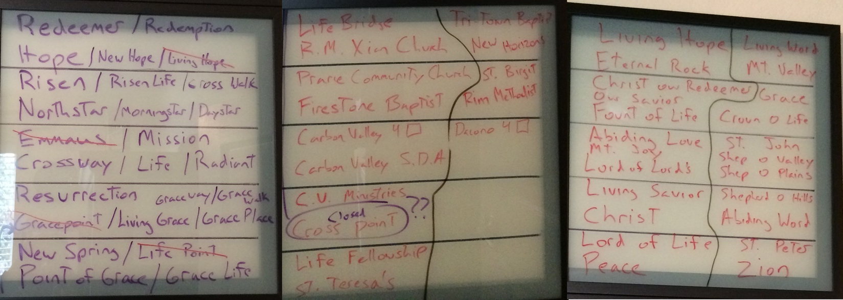
- Family Worshipping in Loveland
- City Email List Sign Up
- 4th @ Firestone Festival
- Preached - Boulder

August Narrative - Restarted our school connections. Volunteering in as many areas as possible in the school. Helped coach soccer at my kids’ school. Getting to know most of the faculty by this point. Found an opening on our city website for a volunteer for the Arts and Cultural Committee. I volunteered and this was an appointed position by the mayor so nice that I already had a relationship with him. Got my picture taken and posted on the city website. Now am getting to know the city employees and most of the city council. Had our first official Mission Meeting. Talked about future plans and focused specifically on our starting Launch Meetings where we would go through Essential church... Got non-profit status, name, logo, website are all in the works. Lots of bouncing ideas off both core members and others especially prospects and random community people. I found their opinions more enlightening than our core. Met with a WELSer who is in advertising. Interesting talk but didn't pan out for much. Preached at Colorado Springs and Eagle.

August
- Arts & Cultural Committee –Mayor, Trustees Bobbi & Samantha
- Engaging WELS members
- School Restarts
- Coaching Soccer – Imagine Public Charter School
- First Official Mission Meeting – Launch Meeting dates and Essential Church.
- Non-profit Status
- Name, Logo, Website – All in the works.
- Odyssey of the Mind Coach
- Friday Folders
- Preached – Colorado Springs, Eagle.

September Narrative - Had two Launch Meetings which went well although small attendance. Settled on our name Carbon Valley Lutheran after considering literally 500 names or so. I basically chose it after taking into consideration many opinions. Logo is now being created. Relationships at school and city hall have progressed and have met tons of people. Checking account is now in place. Needed it early so I could immediately incorporate it into our website for online giving. Wrote a week’s worth of Meditations for synod. Did the Urban presentation in Milwaukee. No discernable "buy in" from core/welsers. Preached at Grand Junction, Thornton, Littleton and Laramie. Devotions at Zion, Denver and Rocky Mountain Lutheran Highschool.

September
- Mission Meetings Begin (ongoing) – Small attendance, every two weeks.
- Name Chosen
- Logo Creation – 99 Designs
- Checking Account Opened
- Incorporated
- Website Domains
- Website Running
- Online Giving
- Facebook
- Miners Day Festival
- Milwaukee Urban Presentation
- Meditations Writing
- Preached - Grand Junction, Thornton, Littleton & Laramie. Devotions at Zion, Denver and Rocky Mountain Lutheran High School.

October Narrative - Helped run local Art show through my volunteering with the city. Soccer coaching came to an end. Jamie is helping coach girls Basketball at our kids school. Websites up and running, multiple domains reserved for any eventuality. Narrowed down future worship site to two and started investigating a Plant nursery which is for sale. I mention this because we are still in the process of possibly buying it. I started thinking of a permanent location before I had ever had a worship service or committed core. Sounds crazy but this kind of advanced brainstorming has to happen if you want to move to the next level should God provide. Launch Meetings continued. Preached in Brighton.

October
- Girls Basketball Coaching
- Art Show
- Future Possible Property – Currently Owned Nursery.
- Worship Sites Narrowed
- Halloween Safe Night Volunteer
- Preached - Brighton

November Narrative - Continued Launch meetings and core/WELS member visits. Investigated in earnest the nursery. Tons of possibility but won't get anywhere because CEF wants to see worship numbers which I don't have as yet. Slower month went to Eau Claire for thanksgiving and shot some deer :) Preached in Aurora.

November
- Church Creeper – Borrowed and stole every bulletin, and worship idea I could find.
- Carbon Valley Help Center
- Thanksgiving
- Shot a Whitetail
- “I Have a Dream” Dinner - Samantha
- Preached - Aurora

December Narrative - Mission Christmas party at my place both WELS and prospects in attendence. First event to bring those two camps together. Football was on, beer was there and catered local business BBQ. Gave a Christmas devotion. Ended up being a great finale to our Launch Meetings. This happened early December like second week so everyone could go to their home churches. Really networking to find a Music Coordinator which is an essential area of need. Logo and website are fully operational by now. Business cards, local paper church directory, etc... all are in place at this point.

December
- Mission Christmas Party
- St Vrain Christmas Walk
- Frederick Christmas Tree Lighting
- Music Coordinator Search
- Community Newspaper – Article in the local paper.
- Worship at Home Churches

2015

January Narrative - Continued Mission meetings. Are now talking vision and "what" CVL will look like. Has started to become more practical. Advanced planning has now secured site and worship dates for the summer preview services. Have started applications and planning for three festival booths in the summer and ads. Applications for MLC Spring Break crew and summer assistants have been placed. Have been asked to be head coach for our school soccer team come spring. Did a church "field trip" to Castle Rock for our group to see what Church in a Box would look like. Incredibly valuable.

January
- Launch Meetings Begin – Vision, look, values.
- Worship Site Secured
- Launch and Preview Dates Set
- Festival Booths – Applications for coming summer festivals submitted.
- Volunteer Applications In – MLC daylight, Summer Canvassers.
- Coaching Spring Soccer
- Church Field Trip – Castle Rock

February Narrative - Slow month. Jamie was super sick and ended up with a trip to Mayo clinic. Launch Meetings continued and ongoing relationships but not tons of new events or contacts happened. Preached in Brighton.

February
- Sick Wife – Trip to Mayo Clinic.
- Preaching Schedule Planned – First year laid out.
- History Lesson – Chatted up local historian who happens to be the mayor.
- Preached – Brighton

March Narrative - Things cranked up this month. Launch meetings continued. 4 guys from MLC came and did a community survey. Survey asked general questions about the community mostly non-religious and we gave $3 gift cards to a local coffee place as a thank you. Great response and encouraging. People really liked the thank you card. We have also started a concerted effort to "keep it local." We support local business and partner with them. This is purposeful because many of the other local churches are satellites of mega churches. We intentionally are billing ourselves as a "local" church which means we also provide personal pastoral care, etc... all things Lutherans are pretty good at. In addition Coloradans love "local." Advanced planning for mass mailers going out coordinating with our Launch date of September 13, 2015. Three mass mailers will precede the launch, as well as a newspaper article. First baptism at CVL. A core member. Subsidy request work is in progress. Preached Highlands Ranch and Castle Rock.

March
- MLC Canvassers – Community survey & coffee cards.
- Love Local Begins
- Core Canvass
- 1st Baptism – In members home.
- Mass Mailer Planning – Design work, cost, frequency, provider.
- Church in a Box Finalization
- Synod Stats – Uhhh…6 souls, 2 communicants.
- Subsidy Request
- Budget Formation
- Preached – Highlands Ranch, Castle Rock

April Narrative - Launch meetings continued prospects are regularly attending these meetings giving good info on our community and insight into the demographic we will be reaching. Did a combo launch meeting/baby shower for the baby we baptized. Preached in Longmont.

April
- Launch Meetings – Attended by member and non-member alike (assimilation already beginning)
- Baby shower
- Music Coordinator – Full court press recruitment.
- Easter – Home churches for worship

May Narrative - Softball practice and team gathering for local WELS softball tourney. Prospects and Welsers involved. Sweet jerseys. Held a practice/BBQ was a good low key way to bring lots of people together. Church in a Box is being finalized and delivery date set. Continued to meet semi regular with the Mayor and city planner concerning the nursery. Good to keep those contacts fresh. Soccer coaching is in full swing. Have met tons of parents and faculty through it. Ran for and won a position for the school board at my kids’ school. Will provide additional opportunities to meet people and be involved. Finalized our music coordinator Arik McGathey and his wife Lisa. Huge answer to prayer. His position is paid for through a one-time donation but will be included in our next subsidy request. Made a trip to Kent Reeders to get up to speed on all thing music. Hugely valuable and worth the trip. Brought Jamie with. Getting ready for our first preview service. Preached at Peace in Boulder, Zion Denver.

May
- Church Softball Practice
- WELS & City Tourney
- Church in a Box Delivered – Training on setup.
- Mayor & City Planner – Met concerning the nursery property.
- Soccer Coaching
- School Board Election
- Music Coordinator Solidified
- South Carolina Music Trip – Music in a Mission Setting with Kent Reeder.
- Festival Booth – Booth at Carbon Valley Half Marathon. Water Bottle giveaway.
- Track & Field Day Imagine
- Preached – Boulder, Zion Denver

June Narrative - Launch Meeting continued. First Preview service. Welsers and closer prospects invited to these services. All advertising points people to Launch. Strong first service. Looked for growth numerically each service and got it leading up to Launch. First mass mailer goes out. Booth at the Carbon Valley Half Marathon. Gave away water bottles. Adopted a new stretch of walking trail as a church. Got our church name on a sign and we will keep the path clean throughout the year.

June
- Launch Meetings – Every week meetings up to first preview service.
- Mass Mailer – First of three. 8,500 homes. All Launch worship focused.
- First Preview Service – Member and non-member alike all involved.
- Signage – 6 road signs, flag, a-frames, interior church in a box set.
- Business Cards – Take home business cards to be used to invite neighbors. Match the mailers.
- WELS Softball Tourney – Got to know the Rec center leadership through this.
- Adopt a Trail – Adopted a new stretch of running trail.

July Narrative - Launch Meetings continued. Second preview service. Second mass mailer goes out. Booth at the 4th at Firestone. Gave away water bottles. 2 MLC girls canvassed with door hangers advertising Launch services. Preached at Castle Rock and Greeley.

July
- Second Mass Mailer
- Festival Booth – 4th @ Firestone booth and water bottle giveaway.
- Second Preview Service
- Canvass – MLC students delivering door hangers advertising Launch Service only.
- Preached – Greeley, Castle Rock

August Narrative - Launch meetings continued. Third preview service. Third mass mailer went out. Booth at Carbon Valley Miners Day. Gave out frisbees. Article in local paper highlighting our work. Literally changed and tweaked stuff every preview service we had right up till launch. Preached in Loveland.

August
- Third Mass Mailer
- Festival Booth – Miners Day and water bottle giveaway.
- Third Preview Service – Dress rehearsal of sorts.
- Newspaper Article Produced
- Preached - Loveland

September Narrative - Launched September 13, 2015. Hired a professional photographer to record the event. Lots of good food. Great start but buoyed by Welser visiting us. Expect a drop and plan for it. Follow up on prospects. Everyone got a box with two coffee mugs and a package of Starbucks on their doorstep within 48 hours. This practice continues every Sunday.

September
- Launched September 13, 2015
- Follow Up Planned – Coffee mugs.
- Thank You Gifts – Water Bottles
- Launch Contacts
- First BIC Grads – January 2016 we welcomed our first group of new members.
- BIC/Connect Groups Begin
- Carbon Kids Begins
- Confirmation Class

Random Later Add On’s
- November, 2015 – Carbon Valley Help Center & Empty Bowls.
- December 2015– First Christmas and choir.
- January, 2016 – First BIC graduates.
- June, 2016 - Love Local – Our first Love Local campaign begins.
- Peel Fundraiser – Local pizzeria raises funds to help us buy our property.
- March, 2017 – Nursery property purchased. 3 ½ acres. Mayor, City Planner instrumental. Multiple clean up days.
- March, 2017 - Pre-school/Daycare Discussions about mutually beneficial use of space (aka renters).
- April, 2017 - K-9 Training – Westminster Police use our newly purchased property for training.
- May, 2017 – Loan Church in a Box curtains to Imagine for school play.
- May, 2017 – Crossfit – Met Ryan a local restaurant owner. Weak 40-year-old body starts breaking down…Crossfit’s short lived.
- December, 2017 - Advent by Starlight.
- January, 2018 – CVL Volleyball Teams – City league coed volleyball. Prospects and member assimilation. Discount from our buddies at the Rec. center.

