OCTOBER 2023 VOLUME 2 Issue 1
MN District Missions Update
Update on Home Missions throughout Minnesota, Iowa, Missouri, and parts of Illinois

In This Issue:
- San Juan (St. John’s) in St. Paul, MN
- New Board Members

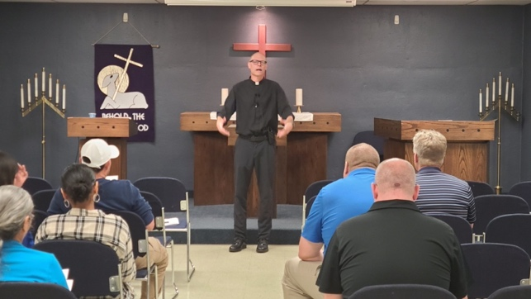
Hispanic Services and Mission Outreach in St. Paul, MN
In spring of 2022, St John’s in St. Paul, MN installed Pastor Tim Otto to serve as pastor to focus on outreach to the Hispanic community. Over the past year, San Juan (St. John’s) has started up Hispanic services and held various local community events.

In September 2023, San Juan had a table at Fiesta Latina. It served to create a prospect list of around 100. The group gave away over 100 Bibles and a lot of flyers advertising their Hispanic ministry. This event was held next door to the church as CLUES (Comunidades Latinas Unidas en Servicio) is located there. St. John’s rents four classrooms to them.

In January 2023, San Juan started an evangelism program to the community called Kicks and Conversations (in Spanish: Patear y Platicar). They invited the community to come out of the cold and to play soccer or basketball in the gym. Attendees could also practice their English on six Wednesdays in January and February leading up to Ash Wednesday. There was good participation as attendance from the community varied anywhere from 10 to 30.

Over the Summer months, San Juan started a summer evangelism program partnering with Raices y Ramas which is the Spanish version of the English pregnancy counseling organization New Day. The program is called Jueves en comunidad (Community Thursdays) and ran for 6 weeks over the Summer. San Juan opened the gym and Anglo volunteers organize and run crafts for the moms. Advertising was done through Facebook, flyers, word of mouth, and WhatsApp.
God is truly blessing the ministry work at St. John’s in St. Paul, MN. St. John’s went from a church that considered closing its doors a few years back to a church that has opened its doors and hearts to a new Hispanic ministry. In St. John’s building the Gospel is preached in Hmong and English and now Spanish. St. John is an old church and they still follow Jesus' same old command to Go and make disciples of ALL nations.
One of the members at St. John’s reflected that through the years when the congregation's direction was unclear to them, she clung to that image of the valley of dry bones (Ez, 37) and God's promise that He can create life where there is none. These days, the vision rests more in Revelation 7:9. What a joy to see God answer in greater fashion than we could ask or imagine: the building now hosts worship in 3 languages every weekend!

The Minnesota District mission board has a direct relationship with St. John’s, Immanuel Hmong, and San Juan. We continue to support and encourage the congregations. God has truly blessed San Juan’s first year and we pray that God would continue to bless this home mission!

For more information on St. John’s/San Juan, please visit their website: www.stjohnev.net

New Minnesota District Missions Board Member

In March 2023, the Minnesota District Mission Board added a new lay member, Glen Schulz, to the board due to the growing focus and work of our home missions and mission enhancements. Glen is from Branson, Missouri and is currently a member at Zion Lutheran in Springfield, Missouri. We welcome Glen to the Minnesota District Mission Board!

New Missions or Enhancements

If you have any Home Mission ideas or questions, the Minnesota District Board would love to work with you to solidify these New Missions and Mission Enhancements. Please contact one of the board members below.

MN District Mission Board & Resources

Rev. Steve Waldschmidt (Chair)
Christ Alone, Dardenne Prairie, MO
pastorsteve@christ-alone.church
(636) 445-0440

Rev. Rev Mark Kaesmeyer
West Lutheran High School, Plymouth, MN
mkaesmeyer@westlutheran.net
(763) 498-9940

Rev. Rob Guenther
St. John’s, New Ulm, MN
pastorguenther@gmail.com
(507) 240-2433

Rev. Mark Birkholz
Mission Counselor
mbirkholz232@gmail.com
(303) 501-2773

Mr. Doug Dorn
St. Paul’s Alexandria, MN
doug.dorn@agcountry.com
(320) 212-6100

Rev. Dustin Sievert
St. Croix Lutheran Academy, West St. Paul, MN
dsievert314@gmail.com
(920) 419-5968

Mr. Daryl Schultz
Resurrection & Life, Rochester, MN
dschultz@us.ibm.com
(507) 261-6906

Mr. Glen Schulz
Zion, Springfield, MO
gbschulz@gmail.com
(262) 263-2345
For additional information on the MN District Home Missions and resources for help with new mission start-ups or mission enhancements, please reference the following website:
www.MNdistrictmissions.com

